**Lab 2**



**Spring 2023**

**DCN LAB**

**Submitted by: Maaz Habib**

**Registration No.: 20PWCSE1952**

**Class Section:** **C**

“On my honor, as student of University of Engineering and Technology, I have neither given nor received unauthorized assistance on this academic work.”

**Submitted to:**

Engr. Yasir Saleem

**Department of Computer Systems Engineering**

**University of Engineering and Technology, Peshawar**

**CSE 303L: Data Communication and Computer Networks**

|  |  |  |  |  |
| --- | --- | --- | --- | --- |
| **Demonstration of Concepts** | **Poor (Does not meet expectation (1))**  The student failed to demonstrate a clear understanding of the assignment concepts | **Fair (Meet Expectation (2-3))**  The student demonstrated a clear understanding of some of the assignment concepts | **Good (Exceeds Expectation (4-5)**  The student demonstrated a clear understanding of the assignment concepts | **Score**  **30%** |
| **Accuracy** | The student mis-configured enough network settings that the lab computer couldn't function properly on the network | The student configured enough network settings that the lab computer partially functioned on the network | The student configured the network settings that the lab computer fully functioned on the network | **30%** |
| **Following Directions** | The student clearly failed to follow the verbal and written instructions to successfully complete the lab | The student failed to follow the some of the verbal and written instructions to successfully complete all requirements of the lab | The student followed the verbal and written instructions to successfully complete requirements of the lab | **20%** |
| **Time Utilization** | The student failed to complete even part of the lab in the allotted amount of time | The student failed to complete the entire lab in the allotted amount of time | The student completed the lab in its entirety in the al | **20%** |

**Credit Hours: 1**

# Lab 02

# Investigate the network using “ping”, “tracert” and other Network related Commands

## OBJECTIVES OF THE LAB

_____________________________________________________________________________________

Following topics will be covered in this lab

* Learn to use the TCP/IP Packet Internet Groper (ping) command.
* Learn to use the Trace Route (tracert) command.
* Observe name resolution occurrences using WINS and/or DNS servers.

**Step 1**

Use the Start menu to open the command-prompt:

Start>Programs>Accessories>Command Prompt or

Start>Programs>Command Prompt

**Step 2**

Type **ping, space**, and **192.168.2.x**. Press Enter key.

Since Ping uses the **Internet Control Message Protocol** (**ICMP**) echo-request and echo-reply feature to test physical connectivity, it reports on four attempts and gives an indication the reliability of the connection. Look over the result and verify that the ping was successful. Was the ping successful? If not, report to the instructor. A successful host ping is shown in Figure 2.1.

**--------------------------------------------TASK 01--------------------------------------------**

1. Ping the IP address of the Default Gateway and DNS Servers. Was the result successful?

**Default gateway: 192.168.14.245**

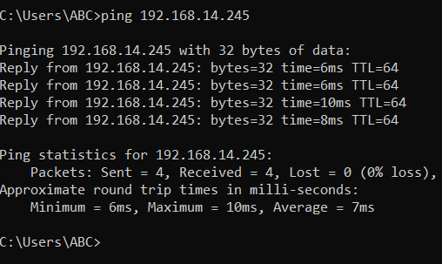

**DNS Server:** **192.168.14.245**

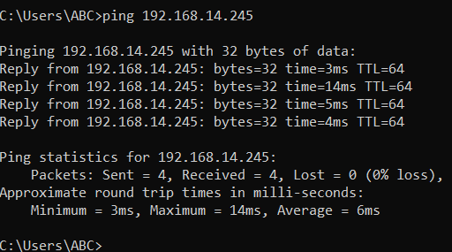

1. **Ping the computer’s loop-back address. Type the following command: >> ping 127.0.0.1**

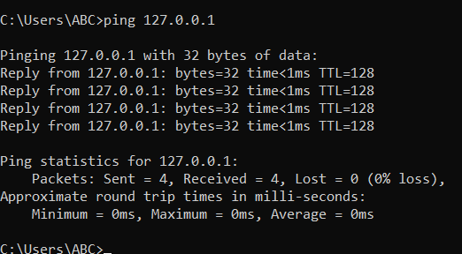

**c)What is the IP Address of** [**www.yahoo.com**](http://www.yahoo.com)**:**

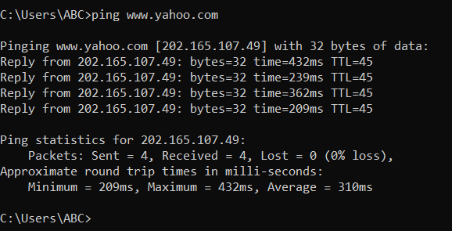

Ip address: 202.165.107.49

**How much time did our ping took to reach** [**www.yahoo.com**](http://www.yahoo.com)**:**

* **Average = 249ms**

1. **Ping the hostname of another computer. Try to ping the hostname of the computer that was recorded in the previous lab.**

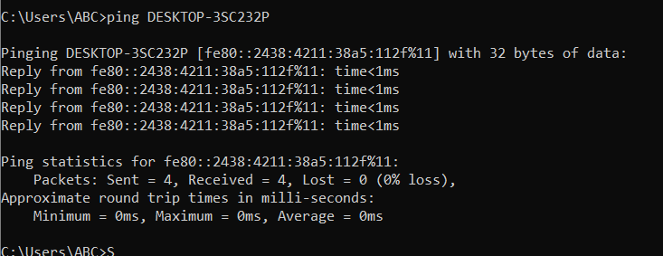

1. **Ping the hostname of another computer using –t. Try to ping repetitively, the hostname of the computer**

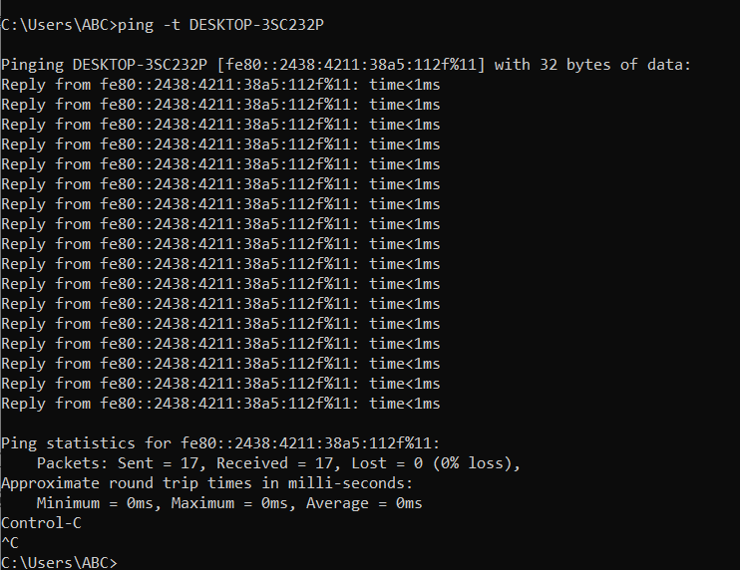

**f) How can we stop the ping?**

* BY pressing **“CTRL C”**

**g)** **ping the IP address of the default gateway**

**Default gateway: 192.168.14.245**



**h) ping the IP address of a DHCP or DNS server**

**DNS Server:** **192.168.14.245**



**Usage**

tracert [-d] [-h maxaimum_hops] [-j host-list] [-w timeout] target_name where target_name can be either IP Address or host name.

**Option Description**

===================================================

**-d (Do Not Resolve** Displays the route using numeric addresses only

**Addresses)** rather than showing both IP address and host

names, for faster display.

**-h maximum_hops (Max.** Specifies the maximum number of hops to use for

**Hops)** tracing; Default is 30

**-w timeout** Specifies how long to wait for a reply to each

Request in milliseconds; Default is 4000 [for 4 sec]

===================================================

**Step 1**

Trace the route to the Yahoo web site

Type tracert www.yaho.com and press Enter.

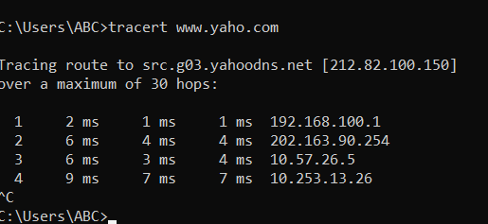

**--------------------------------------------TASK 03--------------------------------------------**

1. Trace the route to the GOOGLE PAKISTAN website by typing:

**>> tracert www.google.com.pk**

The result shows the complete route to the site, along with the number of hops in the path.

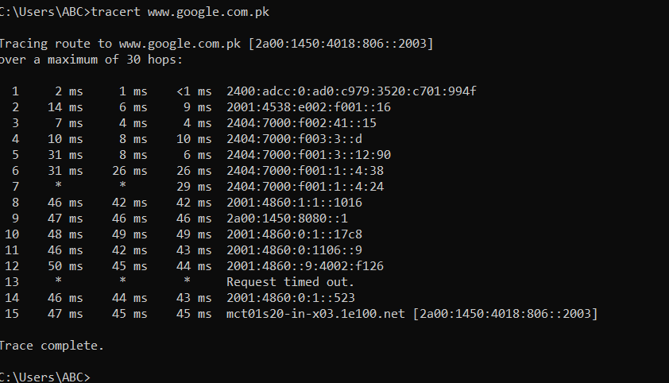

1. Trace the route to the UET website using options listed in option description table.

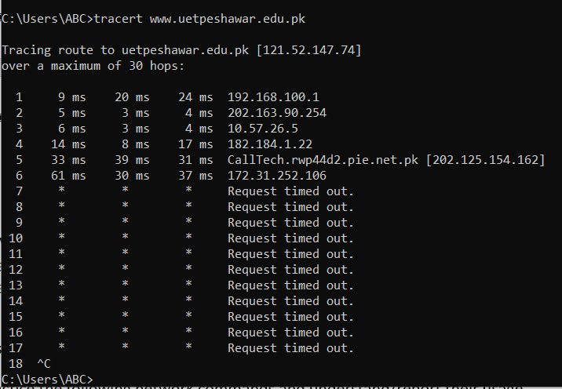

c) What is the difference between the following commands?

Tracert [www.yahoo.com](http://www.yahoo.com)

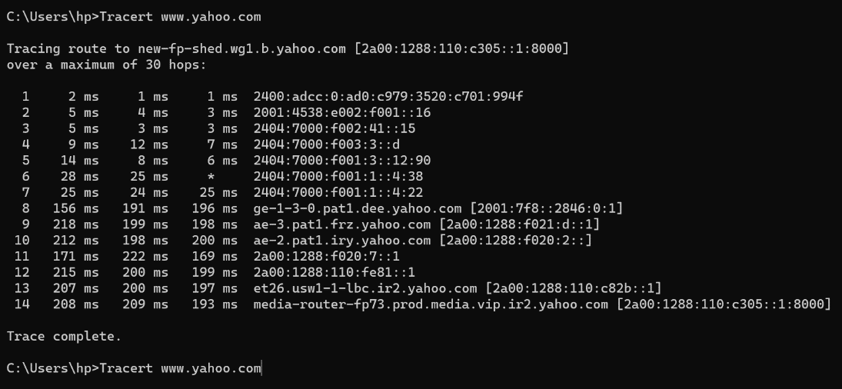

Tracert –h 20 [www.yahoo.com](http://www.yahoo.com)

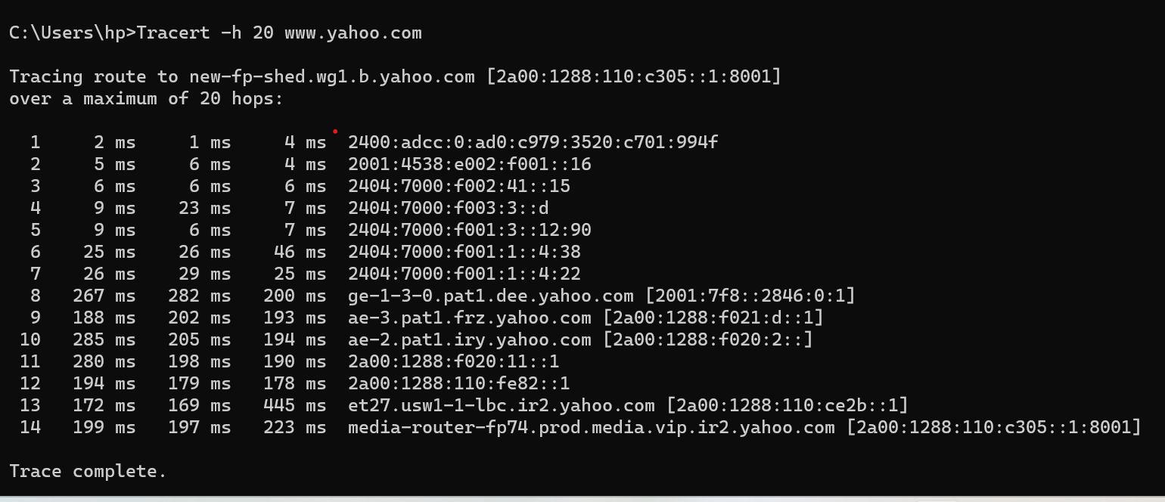

**The difference between them is that by using -h with number we can set the maximum hops we want.**

**----------------------------------------Task 04 (Long Life Learning)** **-----------------------------------------**

Practice the following network commands and understand/report their usage

1. **netstat**  
   Displays active TCP connections, ports on which the computer is listening, Ethernet statistics, the [IP](http://whirlpool.net.au/wiki/IP) routing table, IPv4 statistics (for the IP, ICMP, TCP, and UDP protocols), and IPv6 statistics (for the IPv6, ICMPv6, TCP over IPv6, and UDP over IPv6 protocols). Used without parameters, netstat displays active TCP connections.

**Try the following**

* 1. _ **netstat -a**: Shows the state of all sockets, routing table entries, and interfaces.

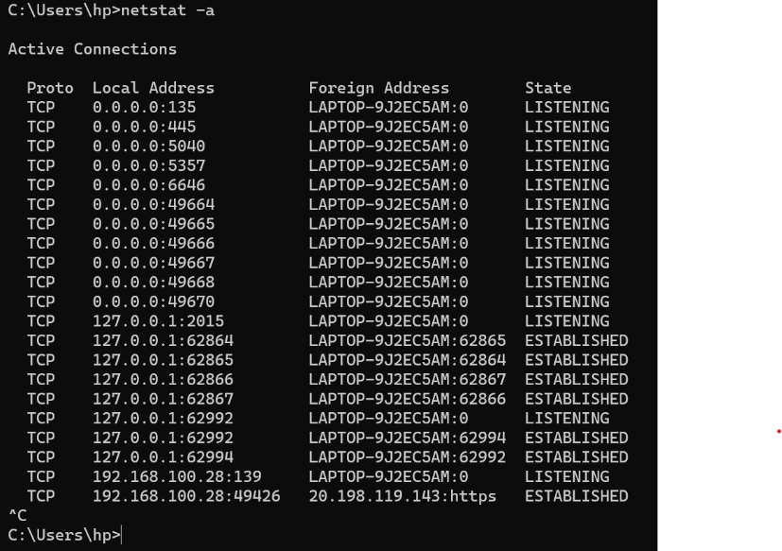

* 1. _ **netstat -r**: Displays the routing table.

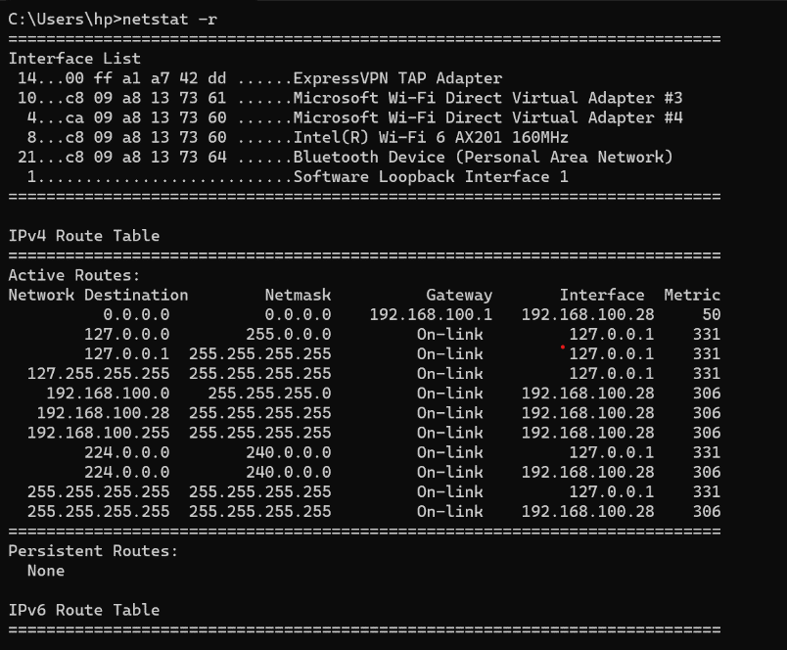

* 1. _ **netstat -i**: Displays the interface information.

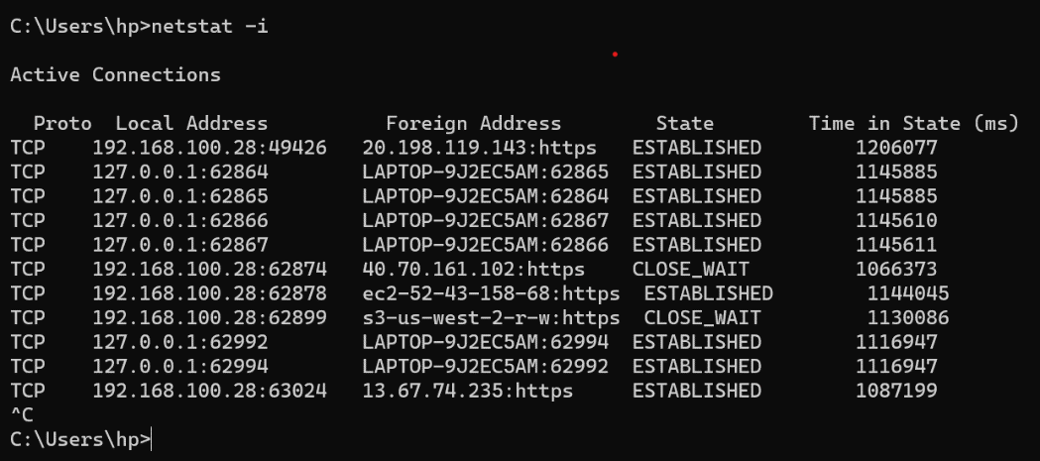

* 1. _ **netstat -n**: Displays numbers instead of names.

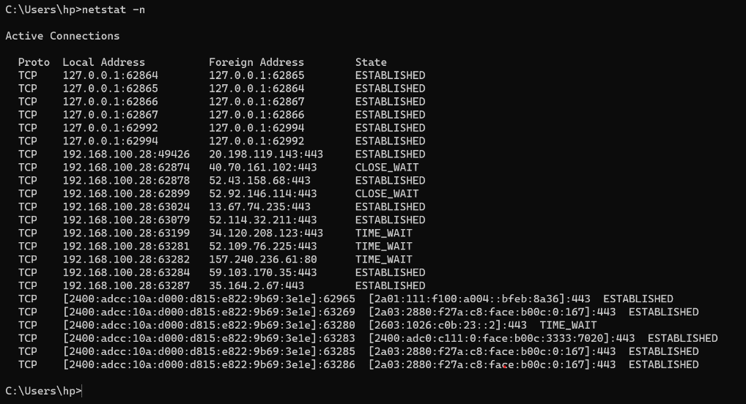

* 1. _ **netstat -s**: Displays per-protocol statistics.

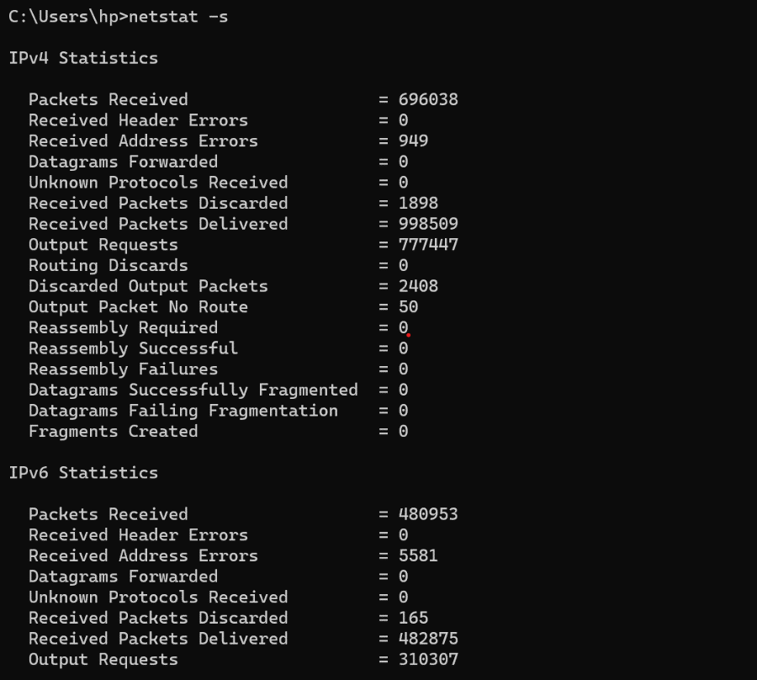

1. **pathping**  
   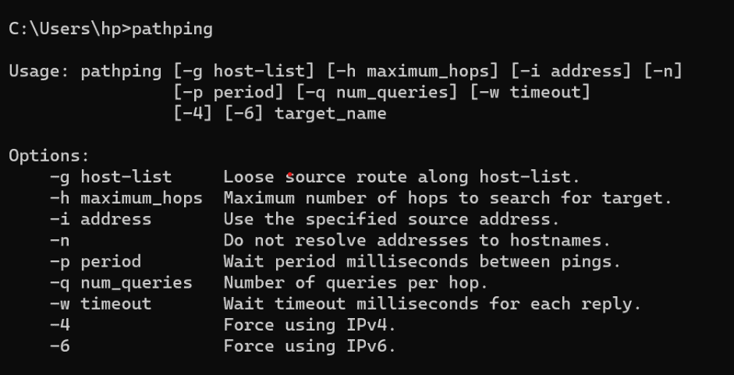
2. **telnet**  
   Telnet is software that allows users to remotely access another computer such as a server, network device, or other computer. With telnet users can connect to a device or computer, manage a network device, setup a device, transfer files, etc.
3. **nslookup**  
   Displays information that you can use to diagnose Domain Name System (DNS) infrastructure. Before using this tool, you should be familiar with how DNS works. The Nslookup command-line tool is available only if you have installed the TCP/IP protocol.
4. **getmac**

Command used to show both local and remote MAC addresses. When run with no parameters (ie. getmac) it displays MAC addresses for the local system. When run with the /s parameter (eg. getmac /s \\foo) it displays MAC addresses for the remote computer. When the /v parameter is used, it also displays the associated connection name and network adapter name.

* **getmac /s 192.168.1.1** – Get MAC Address by IP Address
* **getmac /s localhost** – Get local MAC Address

1. **ARP Command**.

Use **arp -a** to see the entire ARP table.

